For this homework, we were tasked with analyzing a data set from Kickstarter, a crowdfunding tech start-up based out of San Francisco. We are supposed to manipulate existing data in the set, i.e. change Unix timestamps into an excel timestamp, split text into different fields, etc. We were then supposed to analyze the data set by creating different pivot tables and charts that further enhanced our understanding of the data.

The data set was given to us within our homework excel file. The data contains over four thousand rows of data and we actually added some additional columns into this set while completing the homework. The column headings have labels dealing with the status of the projects, the start date and end date of the campaign, the original goal, the amount pledged, the category of the campaign, etc.

There were some limitations with this data set of course. We do not know where the people that invested in the campaigns are from, what their net worth or background are, and the conversions of all the different types of currency that were used at that time and date just to name a few. I am also not sure if amount pledged equates to the project actually being funded. Does pledged mean the payment was actually submitted?

In the homework, we had to use excel functions to get to the data we needed. We had to filter, split, color code, create conditionals, and use pivot tables and charts with the data provided. For some of this homework, I had to research online to ensure my understanding and use of the calculations and formulas.

While working through the analysis, I noticed there were many categories and sub categories of data. Surprisingly, theater had the most success out of any other category. The sub category, plays, had the most success in its area as well. From my personal experience working in a VC crowdfunding tech company, I had no idea that theater and plays had the most success with funding (most of our placements had a minimum investment of five to ten thousand dollars). With that being said, the highest percent of success when it came to raising funds were campaigns trying to raise less than one thousand dollars (71% success). A close second in successful funding were those campaigns trying to reach one thousand to five thousand dollars (66% success).

If my sole priority were to have a successful campaign on Kickstarter, I would create a campaign based on a play. The best rate of successful funding was for those campaigns that had a goal of less than one thousand dollars so I would do my best to keep the goal under that. As far as the timing goes, I would have my campaign launch in May as that month had the highest amount of successful campaigns started.

Pivot and Chart 1 – Category State Breakdown

|  |  |  |  |  |  |
| --- | --- | --- | --- | --- | --- |
| **Count of state** | **Column Labels** |  |  |  |  |
| **Row Labels** | **successful** | **failed** | **canceled** | **live** | **Grand Total** |
| film & video | 300 | 180 | 40 |  | 520 |
| food | 34 | 140 | 20 | 6 | 200 |
| games | 80 | 140 |  |  | 220 |
| journalism |  |  | 24 |  | 24 |
| music | 540 | 120 | 20 | 20 | 700 |
| photography | 103 | 117 |  |  | 220 |
| publishing | 80 | 127 | 30 |  | 237 |
| technology | 209 | 213 | 178 |  | 600 |
| theater | 839 | 493 | 37 | 24 | 1393 |
| **Grand Total** | **2185** | **1530** | **349** | **50** | **4114** |

Pivot and Chart 2 – Sub Category State Breakdown

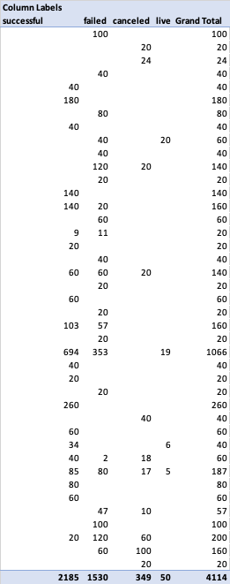

Pivot and Chart 3 – Months State Breakdown

|  |  |  |  |  |
| --- | --- | --- | --- | --- |
| **Count of state** | **Column Labels** |  |  |  |
| **Row Labels** | **successful** | **failed** | **canceled** | **Grand Total** |
| Jan | 182 | 149 | 34 | 365 |
| Feb | 202 | 106 | 27 | 335 |
| Mar | 180 | 108 | 28 | 316 |
| Apr | 192 | 102 | 27 | 321 |
| May | 234 | 126 | 26 | 386 |
| Jun | 211 | 147 | 27 | 385 |
| Jul | 194 | 150 | 43 | 387 |
| Aug | 166 | 134 | 33 | 333 |
| Sep | 147 | 127 | 24 | 298 |
| Oct | 183 | 149 | 20 | 352 |
| Nov | 183 | 114 | 37 | 334 |
| Dec | 111 | 118 | 23 | 252 |
| **Grand Total** | **2185** | **1530** | **349** | **4064** |

Chart 4 – Goal Amount Success Breakdown